Contents
Description 1
Requirements 1
LabView Software Requirements 1
GCSI Hardware and Software Recommendations 1
ICARUS System Requirements 1
Communications 1
Bug Reporting and Feature Requests 2
Installation 2
Software Updates 2
Overview 2
Configuration 3
Setup Tab 3
Connectivity Tab 3
XBee 4
Wi-Fi 5
Cellular 5
SATCOM 5
Google Earth Tab 5
Configuration Tab 6
JAUS Tab 6
Operation 6
Main Tab 6
Manual Tab 6
Autonomous Tab 8
Side Tab 9
Debugger Tab 9
3D Position Tab 10
Command/Control Monitoring Tab 10
Bottom Tab 10
Vehicle Health System Tab 10
Frequently Asked Questions 10
System Performance 10
Troubleshooting 10
Figures 10
Tables 11
Appendix 11

Description
The GCS Interface is a fully featured and Open Source tool for enabling the use of multiple ground and aerial vehicles in a useful and expandable package. The GCSI is programmed primarily in National Instruments LabView, a graphical programming language. Some of the many features of the GCSI include:
Table 1: GCSI Features
Manual Control (keyboard/joystick) of any ground or aerial robotic vehicle.
Autonomous Control of any ground or aerial robotic vehicle.
Google Earth real-time continuous mapping of robotic vehicles.
Multiple communication network types (XBee,Wi-Fi,Cellular, SATCOM).
Audio Feedback

Requirements

LabView Software Requirements
LabView requires a LV Run-Time Engine for your Operating System. Current Operating Systems supported by LV:

Table 2: LV Supported Operating Systems
Operating System | Run-Time Engine Link
Windows
Linux
Mac
NOTE: All Development has been performed in a Windows environment. While LV may be compatible with other Operating Systems, the GCSI in no way guarantees interoperability with other Operating Systems.

GCSI Hardware and Software Recommendations
Besides the requirements listed in the LabView Software Requirements Section, the following are Recommendations for optimal performance and capability with the GCSI.

Table 3: Hardware and Software Recommendations
Recommendation | Justification
2 Displays | Optimal simultaneous viewing of LV and GE Interface’s.

ICARUS System Requirements

Communications
The GCS Interface requires at least one of the following Communications Networks to exist:

Table 4: Communications Network Requirements
Communication Network | Status
XBee | Supported
Wi-Fi | Not Supported (yet)
Cellular | Not Supported (yet)
Satellite Communications | Not Supported (yet)

The ICARUS Communications Protocol must also be followed, which can be found in Appendix XX: ICARUS Communications Protocol Specifications. For information regarding the implementation of the ICARUS Communications Protocol, see Appendix XX: ICARUS Communications Protocol Guide.

Bug Reporting and Feature Requests

Installation

Software Updates
The most recent version of the GCS-Interface can be found here:

Overview
The GCSI has two main screens, the LabView Interface and the Google Earth Interface.
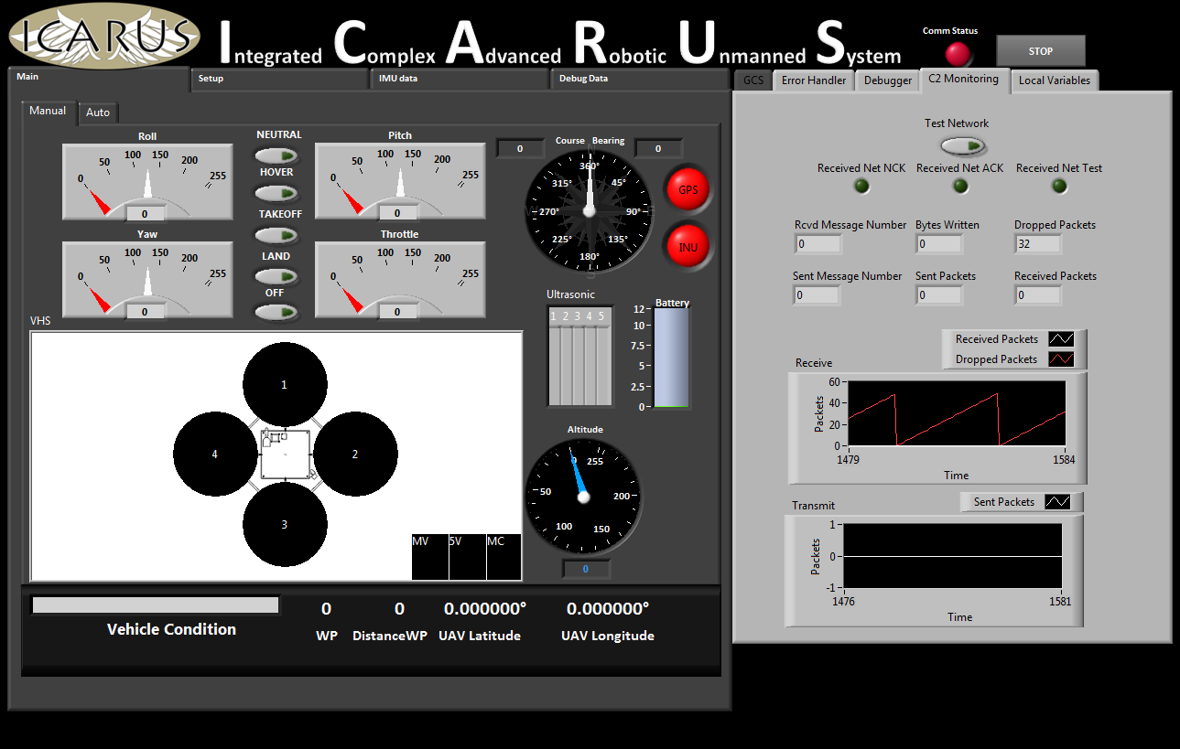
Figure 1: LabView Interface

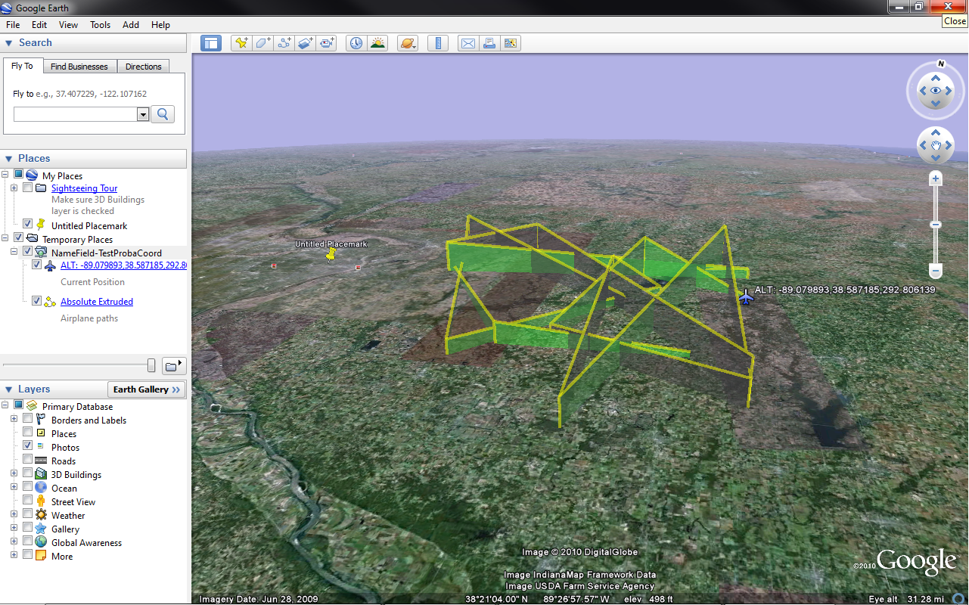
Figure 2: Google Earth Interface

Configuration

Setup Tab

Connectivity Tab
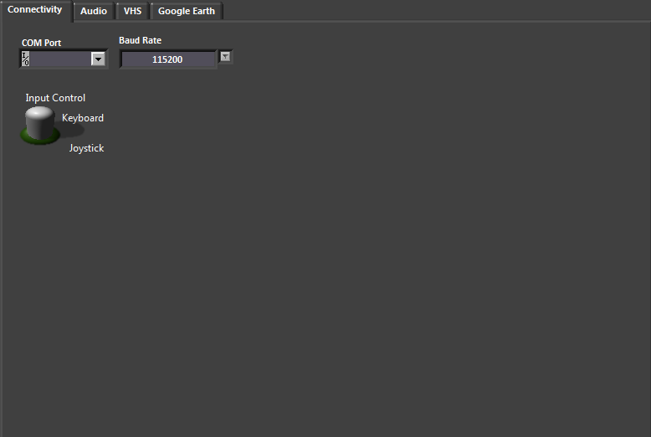
Figure 3: Connectivity Configuration Tab

XBee

Non-API Mode:

API Mode:

Wi-Fi

Cellular

SATCOM

Google Earth Tab
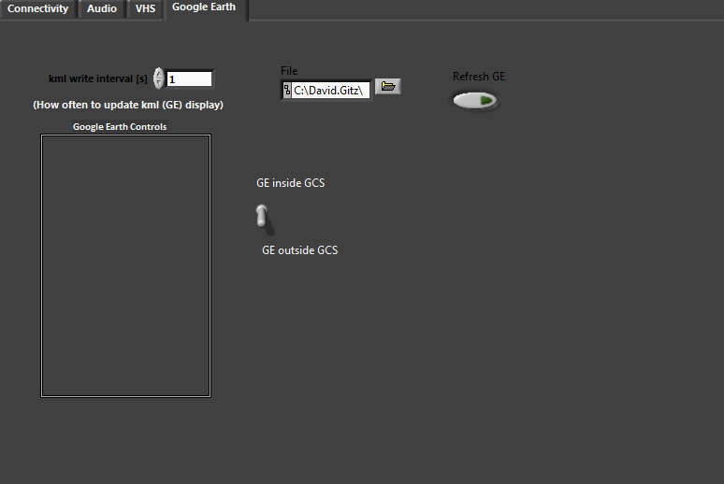
Figure 4: Google Earth Configuration Tab

Configuration Tab

JAUS Tab

Operation

Main Tab

Manual Tab
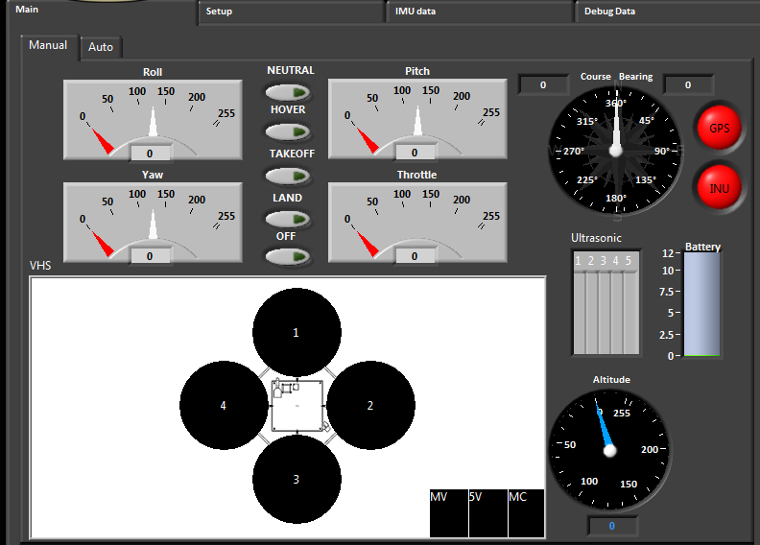
Figure 5: Manual Tab

The Manual Tab displays Sensor readings and other data reported from the Vehicle. The following indicators have been implemented:
- Course/Bearing Gauge
  - Bearing: The compass angle of the Vehicle with respect to its next waypoint.
  - Course: The compass angle of the Vehicle with respect to Magnetic North.
- Altitude:
  - Altitude over Datum: Altitude reported by GPS Device
  - Altitude over Ground: Altitude reported by other Sensors, such as barometric or distance sensors.
- Ultrasonic: Each Ultrasonic sensor reports how far away it sees an obstacle, in inches.
- Battery: Battery Voltage, maximum is 13V.
- GPS FIX: Indicates receiving GPS Position Data.
- INU FIX: Indicates receiving INU Orientation Data.
- Pitch/Roll/Yaw: Indicates INU Orientation Data for each Axis.
- UAV Latitude/Longitude: GPS Position Data.
- WP: Next Waypoint Number.
- WP Distance: Distance to Next Waypoint, in feet.

Autonomous Tab
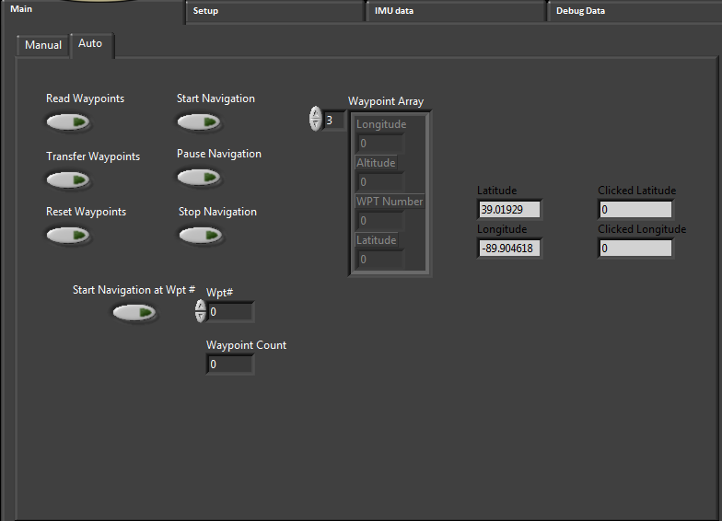
Figure 6: Autonomous Tab
Waypoints are created on the GE Interface (or alternatively inputted manually on the Autonomous Tab). To erase the Waypoints, click Reset Waypoint.

Side Tab

Debugger Tab
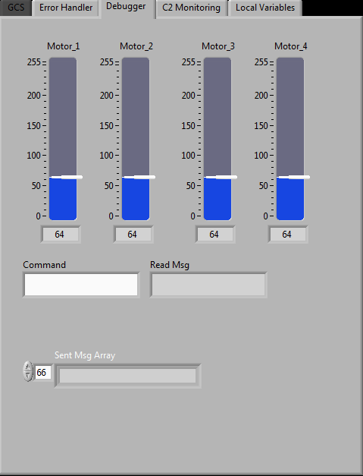
Figure 7: Debugger Tab

3D Position Tab

Command/Control Monitoring Tab
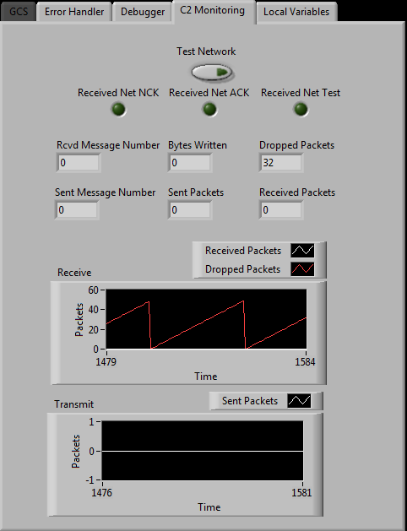
Figure 8: Command/Control Monitoring Tab

Bottom Tab

Vehicle Health System Tab
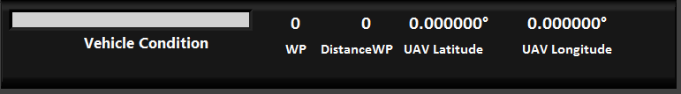
Figure 9: Vehicle Health System Tab

- Vehicle Condition: Provides overall status of Vehicle. Conditions Include:
  - NORMAL:
    - Battery Voltage Nominal.
    - No Error Codes.
    - Main Current Nominal.
  - LAND SOON:
    - Battery Voltage decreasing. Land soon before Batteries are too low to land Vehicle safely.
  - NO COMMUNICATIONS:
    - No communication with Vehicle.
    - Lost communication with Vehicle.
    - A large number of are Packets being received but are not recoverable.
  - EMERGENCY LANDING:
    - Vehicle was being flown but due to the following reasons, EMERGENCY LANDING Procedures have been implemented automatically.
      - No Communications for X Seconds.
      - Battery Voltage < X and Altitude over Ground > X.
      - Pitch,Roll,Yaw,Throttle or Altitude over Ground uncontrollable.
      - Loss of Critical Components: Primary Controller, GPS.
  - EMERGENCY RECOVERY:
    - Vehicle was being flown but due to the following reasons, EMERGENCY RECOVERY Procedures have been implemented automatically.
      - EMERGENCY LANDING Procedure not appropriate or not possible.
      - No Communications for X Seconds.
      - Battery Voltage < X and Altitude over Ground > X.
      - Pitch,Roll,Yaw,Throttle or Altitude over Ground uncontrollable.
      - Loss of Critical Components: Secondary Controller, Main ESC’s.

Frequently Asked Questions

System Performance

Troubleshooting

Figures
Figure 1: LabView Interface 2
Figure 2: Google Earth Interface 3
Figure 3: Connectivity Configuration Tab 4
Figure 4: Google Earth Configuration Tab 5
Figure 5: Manual Tab 6
Figure 6: Autonomous Tab 8
Figure 7: Debugger Tab 9
Figure 8: Command/Control Monitoring Tab 10
Figure 9: Vehicle Health System Tab 10

Tables
Table 1: GCSI Features 1
Table 2: LV Supported Operating Systems 1
Table 3: Hardware and Software Recommendations 1
Table 4: Communications Network Requirements 1

Appendix
XX: ICARUS Communications Protocol Guide
XX: ICARUS Communications Protocol Specifications

XX: Source Code

